POLICY TITLE | WHISTLEBLOWER POLICY
POLICY ESCRIPTION | This Policy provides a framework which helps to identify instances of wrongdoing and provide guidance on how to raise a concern about suspected or actual unethical or unlawful behaviour.
Date of Approval | June 2019, June 2020, June 2021, June 2022
Review Date | June 2023
Responsible Officer | Chief Executive Officer
Related Policy Framework | HR POLICIES  COMPLAINTS HANDLING POLICY  FRAUD AND CORRUPTION  COUNTER TERRORISM AND MONEY LAUNDERING  ACFID Code of Conduct

Purpose of the Policy

The purpose of this policy is intended to encourage Board members, staff, volunteers, and others to report suspected or actual occurrence (s) of illegal, unethical or inappropriate events (behaviours or practices) without retribution. This policy is based on ACCF’s commitment to accountability and transparency. This policy is to provide a supportive work-relationship environment where misconduct can be raised without fear of retribution. This can be achieved by:

• encouraging the reporting of serious misconduct
• providing protected misconduct reporting alternatives to remove inhibitions that may impede such disclosures
• establishing procedures that enable:

- protection for those that make serious misconduct disclosures
- independent internal inquiry/investigation of disclosures made
- resolution of the issue(s) identified

Policy Overview

ACCF is committed to operating in accordance with ACCF’s Constitution’s purpose and in compliance with all applicable laws, rules and regulations, including those concerning fraudulent practices by any of its board members, employees, or volunteers. This policy outlines a procedure for employees to report actions that an employee reasonably believes violate a law, or regulation or that constitutes fraudulent accounting or other practices. This policy applies to any matter which is related to ACCF’s business and does not relate to private acts of an individual not connected to the business of ACCF. No

he
Scope and Application

1. A whistle-blower should report instances of, or suspicions of misconduct to ACCF’s Chief Executive Officer (CEO) or delegate. Reports must be made in good-faith and be as thorough as is possible. False or malicious allegations may result in disciplinary actions.
2 The CEO will contact the Chair of the Board. Both parties will agree on the appointment of an appropriate delegate, who is not implicated in the report, to lead the investigation. This would normally be the CEO.
3. The individual who leads the investigation will be referred to as the Whistle-blower Protection Officer and should either be a qualified internal investigator who is independent of the area where the wrongdoing is alleged to have occurred, or a qualified external investigator independent of ACCF.
4. The responsibilities of the appointed investigator include the assurance that action taken in response to the inquiry is appropriate to the circumstances and retaliatory action will not be taken against the person who made the disclosure.
5. The investigator has direct, unfettered access to independent financial, legal, and operational advisers as required.
6. The Whistle-blower Protection Officer is also responsible for keeping the Whistle-blower informed of the progress and outcomes of the inquiry/investigation subject to considerations of privacy of those against whom the allegations have been made.
5.13 The internal investigator must have internal independence of line management of the area affected by the wrongdoing disclosure. The internal investigator is authorised to apply the powers granted by the Chair of ACCF’s Board.

5.14 Whistle-blower
1. The Whistle-blower should promptly report the suspected or actual event to his/her supervisor.

2. If the Whistle-blower is uncomfortable or otherwise reluctant to report to his/her supervisor, then the Whistle-blower could report the event to the next highest or another level of Management, including the Chief Executive Officer or an appropriate Board committee or member.

3. The Whistle-blower can report the event with his/her identity or anonymously.

4. The Whistle- blower shall receive no retaliation or retribution for a report that was provided in good faith – that was not done primarily with malice to damage another or the organisation.

5. A Whistle-blower who makes a report that is not done in good faith is subject to discipline, including termination by the Chief Executive Officer/ Board or other legal means to protect the reputation of the organisation and members of ACCF’s Board and staff.

6. Anyone who retaliates against the Whistle-blower (who reported an event in good faith) will
be subject to discipline, including termination.

7. Crimes against person or property, such as assault, rape, burglary, etc., should immediately
be reported to local law enforcement personnel.

8. Supervisors, managers, the Chief Executive Officer and/or Board members who receive the reports must promptly act to investigate and/or resolve the issue.

9. The Whistle-blower shall receive a report within five business days of the initial report, regarding the investigation, disposition, or resolution of the issue.

10. If the investigation of a report, that was done in good faith and investigated by internal personnel, is not to the Whistle-blower’s satisfaction, then he/she has the right to report the event to the appropriate legal or investigative agency.

11. The identity of the Whistle-blower, if known, shall remain confidential to those persons directly involved in applying this policy, unless the issue requires investigation by an appropriate legal or investigative agency. The Whistle-blower will always be protected while an investigation is taking place.

12. This policy should be read in conjunction with ACCF’s Complaint Handling Policy (P011).

Policy Statement

If an employee has a reasonable belief that an employee, volunteer of ACCF including the CEO has engaged in any action that violates any applicable law, or regulation, including those concerning accounting and auditing, or constitutes a fraudulent practice, the employee is expected to immediately report such information to the Chief Executive Officer/or delegate or Chair of the Board if the CEO is implicated.

All reports will be followed up promptly, and an investigation conducted. In conducting its investigations, ACCF will strive to keep the identity of the complaining individual as confidential as possible, while conducting an adequate review and investigation.

ACCF may take disciplinary action (up to and including termination) against an employee who in Management’s assessment has engaged in retaliatory conduct in violation of this policy

Applicable staff will be trained on this policy and ACCF’s prohibition against retaliation in accordance with this policy.

This policy will be made available on ACCF’s website for easy access to all staff, volunteers, and other stakeholders along with ACCF’s Complaints Handling Policy.

Procedures

All ACCF staff will be made aware of this policy and their responsibilities to report wrongdoing to the Chief Executive Officer. It is the responsibility of the Chief Executive Officer to ensure all staff are adequately trained in understanding, identifying and (where possible) mitigating any activity that may breach the definitions of fraudulent or corrupt behaviour. Refer above to Scope and Application.

If there is any concerns that the Chief Executive Officer has violated any laws including financial wrongdoing then the matter should be referred to the Chair of the Board.

Definitions

Definitions for this policy

Whistleblowing is:

The disclosure by or for a witness, of actual or suspected misconduct in an organisation that reveals fraud, corruption, illegal activities, gross mismanagement, malpractice, or any other serious wrongdoing.

A Whistle-blower is:

A person who reports serious misconduct in accordance with this policy

Descriptions of misconduct for this policy

Misconduct includes behaviour that:

• is fraudulent or corrupt
• is illegal
• is unethical, such as acting dishonestly; altering company records; wilfully making false entries in official records; engaging in questionable accounting practices; or wilfully breaching ACCF’s Code of Conduct including ACFID Code of Conduct
• is potentially damaging to ACCF
• is seriously harmful or potentially seriously harmful to ACCF’s employee or volunteer such as deliberate unsafe work practice or wilful disregard to the safety of others in the workplace
• may cause serious financial or non-financial loss to ACCF; or damage its reputation; or be otherwise seriously contrary to ACCF’s Whistle-blowing policy
• involves any other kind of serious impropriety including retaliatory action against a whistle-blower for having made a wrongdoing disclosure

References

ACFID Code of Conduct – Commitment 8.2

APPROVAL

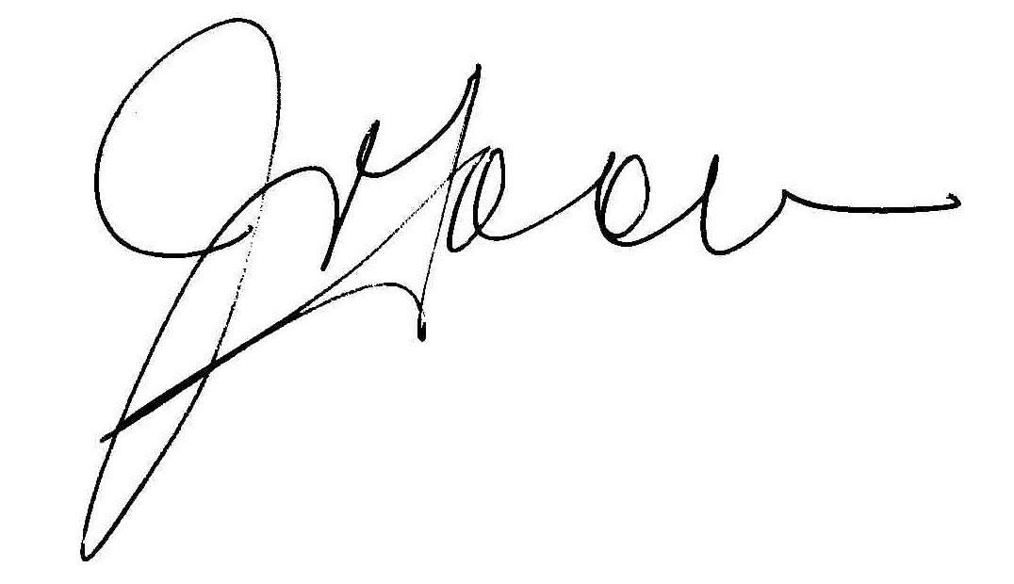
Approved by the CEO: Mr. J. Tooma Date: 30 /06 /2022

Approved by the Board: Mr. G. Lade Date: 30 /06/ 2022

Date for review: 30/06/2023

https://accforg.sharepoint.com/sites/ACCF_Operations_and_Admin_Team/Shared%20Documents/General/ACCF%20POLICIES/2-%20Board%20&%20Governance/G-005%20Whistleblower%20policy.docx

