Policy Title | Child Safeguarding Policy
Policy Description | A policy that formally sets out the Australian Cervical Cancer Foundation’s (ACCF) commitment to its duty of care to ensure that all programs and projects promote child safe practices and safeguard children from harm.
Date of Approval | June 2019, June 2020, June 2021, June 2022
Review Date | June 2023
Responsible Officer | Chief Executive Officer
Related Policy Framework | Memorandum of Understanding between our International Partners  ACFID Code of Conduct  ACFID Code of Compliance  ACCF’s Internal Policies

Mission, values, purpose and nature of programs

ACCF’s Mission in Australia and Overseas
ACCF’s vision and mission is to protect and enhance women’s health to help overcome disadvantage, by eliminating cervical cancer and enabling treatment and support for women with cervical cancer and related health issues in Australia and in developing countries.
The mission of ACCF is to minimise the incidence and burden of cervical cancer and related women’s health issues: to assist women, their families, and communities by developing and implementing practical and appropriate programs, and by partnering with like-minded government, organisations, and individuals to achieve health outcomes which reduce marginalisation and contribute to developing stronger communities.
ACCF’s Vision
Through its programs in support of women’s health and wellbeing, ACCF is committed to improving health and reducing poverty and disadvantage to contribute to sustainable development. ACCF and its program partners have a policy of zero tolerance to fraud and corruption and to family and sexual violence, particularly against women.
ACCF’s Purpose

The principal activities of the company are to carry out its public charitable purposes of preventing cervical cancer, by:
- Promoting and facilitating screening for cervical cancer
- Promoting awareness and prevention of cervical cancer.
- Supporting women living with cervical cancer and related women’s health issues, and their families.

- Purpose of the Policy

  - This policy sets out the framework for promoting child safe practices and safeguarding children from harm. ACCF will provide effective leadership to ensure the safeguarding of children, the policy makes clear ACCF’s commitment to ensure that we advance the safeguarding of children. It provides the guiding principles and approach towards implementation to ensure its commitment is incorporated in all areas of its work and applies to anyone who represents ACCF.

- Scope

  - This policy applies to anyone who represents ACCF, including but not limited to staff, volunteers, partners (local NGOs, affiliates, and government counterparts), contractors, donors and board members.

  - This policy applies to board members, staff, volunteers, and contractors of partner organisations implementing aid and development activities funded by or through ACCF.

  - The Chief Executive Officer is responsible for promoting Child Safeguarding throughout the organisation including communication and providing education around the risks if ACCF does not commit to the safeguarding of children.

- Commitment/Background

  - ACCF is strongly committed to protecting children and aligns its principles with the United Nations Convention on the Rights of the Child (UNCRC), Article 19, which states that all measures shall be taken to protect children (regardless of gender, country of origin, race or religious belief) from all forms of physical or mental violence, injury or abuse, neglect or negligent treatment, maltreatment or exploitation, including sexual abuse, while in the care of parent(s), legal guardian(s) or any other person who has the care of the child.

  - ACCF is committed to ensuring that its practises exhibit the highest standards of accountability, transparency, sustainability, safeguarding of human rights, engagement of communities and continuous improvement. ACCF aligns its principles with the Australian Council for International Development’s (ACFID) Code of Conduct.

  - ACCF is committed to the communication of the Child Safeguarding Policy and Code of Conduct and practices to all its stakeholders who represent ACCF, including but not limited to staff, volunteers, partners (local NGOs, affiliates, and government counterparts), contractors, donors and board members.

- Policy

  - Code of Conduct
    - When working with children, all representatives of ACCF will:
      - listen to children and where appropriate allow them to have a say in the decisions that affect them.
      - immediately raise any concerns for the safety or wellbeing of a child in accordance with ACCF’s reporting process.
      - treat every child with dignity and respect regardless of differences of ethnicity, religion, age, ability, gender, sexual orientation and economic circumstances.
      - be aware of cultural differences and sensitivities.
      - conduct themselves in a manner consistent with their position as a positive role model to children and as a representative of ACCF.
      - avoid being alone with a child where practicable; and
    - try to ensure that other adults are present when working with a child. When working with children, all representatives of ACCF will not:
      - photograph or video a child without the consent of the child and his or her parent/s or guardian/s, use of images and personal information for promotion, fundraising and development education which ensures the privacy and safeguarding of children.
      - act in ways that may be abusive or place a child at risk of abuse.
      - avoid physical contact with a child. Do not smack, hit or physically assault a child.
      - engage in any behaviour that is intended to shame, humiliate, belittle or degrade a child.
      - use of inappropriate language, make suggestions, or offer advice that is inappropriate, offensive or abusive.
      - take a child to one’s hotel or lodgings, nor sleep alone in the same room or share a bed with a child who is not one’s own.
      - take a child unaccompanied to the toilet or bathe them unsupervised.
      - develop sexual relationships with a child or relationships that can in any way be deemed exploitative.
      - behave physically in a manner that is inappropriate or sexually provocative.
      - condone, or participate in, behaviour which is illegal, unsafe, or abusive, including child labour.
      - hold, kiss, cuddle or touch a child in an inappropriate, unnecessary, or culturally insensitive way.
      - do not provide any gifts to children including alcohol and drugs

  - Screening, Recruitment, Training and Ongoing Review
    - ACCF engages in child safe recruitment of its employees and volunteers who engage with children as part of their role within the organisation. ACCF conducts relevant searches including a criminal record check and Working with Children check before engagement to ensure child safe recruitment is effective within the organisation. Statutory declarations of local legal equivalent where criminal record checks are unavailable or unreliable are acceptable. The interview process includes behavioural based interview questions along with other appropriate interview questions. As part of the selection process, referee checks are carried out prior to engagement.
    - Employment contracts contain provisions for the prevention of a person working with children if they present an unacceptable risk to children; dismissal, suspension, or transfer to other duties for any employee who breaches the Child Safeguarding Policy and Code of Conduct. Any person with a criminal history or record of child abuse will not be employed by ACCF.
    - The ACCF Child Safeguarding Policy and Code of Conduct is a core module of the induction training of new staff.
    - The ACCF Child Safeguarding Policy and Code of Conduct forms a part of ACCF’s program package, which requires representatives of ACCF to review and understand their responsibilities in the discharge of their duties whether in Australia or overseas.
  - Photographing or Filming of Children
Representatives of ACCF must:
    - Never take photographs or videos of anyone who has requested that you refrain from doing so.
    - Prior to photographing or filming a child:
      - Respect and comply with local standards and traditions and adhere to any restrictions relating to photographing, filming, and reproducing images of children.
      - Explain to the parent or guardian how the photograph or film will be used. This may include an explanation of the likely use of the image(s), for example, website, newsletters, and email notifications to subscribers.
      - Obtain the consent of the parent or guardian to use the photograph or film.
    - Protect the personal identity of a child in all aspects and specifically when sending images electronically (this includes sending any images via email). Ensure that no image can identify a child and place them in a compromising situation.
    - Ensure that all images are honest representations of the context and facts. This may require the insertion of accompanying text providing an explanation of context and facts to ensure an honest representation is maintained.
    - Ensure that standards of decency and taste (this includes an understanding of what is tasteful by the relevant cultural standard) are maintained and that any images of children are respectful of the child’s dignity.
    - Ensure that images do not portray a child in a submissive manner or in poses that may be seen as sexually suggestive.
    - Not crop or digitally enhance an image in such a way that it changes the context, reality, is misleading of the facts or does not maintain the child’s dignity in any way.
    - Ensure that images of children are stored securely and access to such images is restricted.

- Application and Implementation of Policy

  - Reporting
All ACCF staff, volunteers and representatives must report all concerns or allegations relating to child abuse or neglect immediately. Concerns may relate to a child involved in ACCF programs, an ACCF representative or a child or person outside of ACCF’s programs. All incidents or concerns must be recorded in the Child Incident Report (Schedule 1).
    - What Must Be Reported
      - Behaviour/actions which must be reported include but are not limited to the following:
        - Any behaviour exhibited by an ACCF staff, volunteer or other relevant stakeholder/representative that breaches the ACCF code of conduct for working with children.
        - Inappropriate use of images, including evidence of child pornography.
        - Any behaviour considered to be a criminal offence in the State or Territory of Australia or the country within which the offence is committed.
        - Behaviour that could be associated with sexual exploitation or trafficking; and
        - Any disclosure or allegation from a child, community member or ACCF representative regarding the safety, welfare, abuse, neglect, or exploitation of a child.
    - Who to Make a Report to
      - In Australia
        - In Australia, sexual and physical abuse of a child is a crime. Child abuse must be reported to the local police and/or child protection authorities in the relevant State or Territory.
        - Any concerns relating to child abuse, neglect or the welfare and safety of a child must be reported to the Chief Executive Officer of ACCF or the chairman of the Board. All incidents or concerns must be recorded in the Child Incident Report (Schedule 1).
          - ACCF must report any allegations or suspicions of child abuse or neglect by an ACCF representative to the State police and/or child protection authorities in the relevant State or Territory.
          - ACCF must report any allegations or suspicions of child abuse or neglect by someone external to ACCF to the State police and/or child protection authorities in the relevant State or Territory.
        - Anyone who suspects on reasonable grounds that a child is in danger must contact police in the relevant State or Territory immediately.
        - Any allegations of persons engaging in child sex tourism, child sex trafficking and child pornography must be reported to the Australian Federal Police (“AFP”) Operations Monitoring Centre (“AFP OMC”) in the relevant State or Territory where the suspected offences occurred.
      - Overseas
        - It is a crime for Australian citizens, permanent residents, or bodies corporate to engage in, facilitate or benefit from sexual activity with children (under 16 years of age) while overseas. The AFP has a role in preventing, disrupting, and investigating Australians who are associated with such offences, in conjunction with relevant State, Commonwealth and international law enforcement partners. To protect children overseas, the Australian Government has created offences for this behavior under the Commonwealth Criminal Code Act 1995. It is also an offence to prepare for or plan to commit a child sex tourism offence, or to groom or procure a child for sexual activity overseas. The Australian Federal Police actively monitors and prosecutes those involved in child sexual exploitation in travel and tourism.
        - Any concerns relating to an offence as set out in clause 5.1.2.2.1 must be reported to the Chief Executive Officer of ACCF or the Chairman of the Board. All incidents or concerns must be recorded in the Child Incident Report (Schedule 1).
          - ACCF must report any allegations or suspicions of an offence as set out in clause 5.1.2.2.1 by an ACCF representative to the Australian Federal Police (or the State police and/or child protection authorities in the relevant State or Territory if the matter does not fall within the jurisdiction of the AFP).
          - ACCF must report any allegations or suspicions relating to an offence as set out in clause 5.1.2.2.1 by someone external to ACCF to the Australian Federal Police (or the State police and/or child protection authorities in the relevant State or Territory if the matter does not fall within the jurisdiction of the AFP).
        - Any allegations of persons engaging in child sex tourism, child sex trafficking and child pornography must be reported to the Australian Federal Police (“AFP”) Operations Monitoring Centre (“AFP OMC”) in the relevant State or Territory where the suspected offences occurred.
  - Guidance Notes
    - ACCF will treat all concerns seriously and any assessments of such concerns will have regard to the best interests of the child as the paramount consideration.
    - ACCF will use its best endeavors to ensure that the interests and safety of the child and the person making the report are protected throughout the investigation.
    - ACCF will treat all parties fairly and handle all matters expeditiously and confidentially.
    - Any person who intentionally makes false and malicious allegations will face disciplinary action.
    - This policy cannot provide guidance for every circumstance and in some situations the application of this policy may be difficult. In this regard, ACCF will apply the spirit and intent of this policy having regard to the best interests of the child as the paramount consideration to each situation.
  - Ongoing Review
    - This policy will be reviewed annually to ensure that it continues to comply with best practice standards.
  - Confidentiality
    - All reports, names of people and any information disclosed pursuant to this policy will be considered sensitive and confidential and will only be disclosed on a need-to-know basis to persons bound by the ACCF Confidentiality Deed and, when required, to the Australian Federal Police or the State police and/or child protection authorities in the relevant State or Territory.
  - Parties to this Policy
    - This policy will be included in:
      - All employment and volunteer contracts; and
      - Memorandums of understanding with partner organisations.
    - All employees, volunteers and partner organisations must sign the ACCF Child Safeguarding Policy and Code of Conduct (Schedule 2).

- Risk Management Tools and Guidance

Below is a set of scenarios and recommended actions to take to mitigate and eliminate risks.

Definitions

Child Any person under the age of eighteen (18) years as defined by the Convention on the Rights of the Child.
Child Protection An activity or initiative designed to protect children from any form of harm, particularly arising from child abuse or neglect.
Child Abuse Child abuse involves the abuse of children’s rights, and includes all forms of physical, emotional and sexual abuse, domestic violence, neglect, commercial sexual exploitation, child trafficking, grooming and child labour as defined below.
Grooming The term “grooming” a child for sexual abuse relates to the act of building the trust of children and/or their carers to gain access to children in order to sexually abuse them. Grooming is also considered child abuse.
Physical Abuse When a person purposefully injures, or threatens to injure, a child. Examples include, but are not limited to - slapping, punching, shaking, kicking, burning, shoving or grabbing.
Emotional Abuse A persistent attack on a child’s self-esteem. Examples include, but are not limited to - name-calling, threatening, ridiculing, intimidating or isolating the child.
Neglect The persistent failure or the deliberate denial (where there are means) to provide a child with clean water, food, shelter, sanitation or supervision or care to the extent that the child’s health and development are placed at risk.
Sexual Abuse When a child is used by another child, adolescent or adult, for his or her own sexual stimulation or gratification. Sexual abuse involves contact and non-contact activities, which encompasses all forms of sexual activity involving children, including exposing children to pornographic images, or taking pornographic photographs of children.

Domestic Violence This includes verbal, physical, sexual or emotional violence within the household or family, which the child witnesses, usually on a regular basis.

Commercial Sexual
Exploitation Where a child is sexually abused or exploited in return for cash or for kind.

Child labour Where the type and frequency of work that a child of a particular age is required to do exceeds ACCF’s guidelines. Such work is considered harmful to the child and should therefore be eliminated.

Child Trafficking Relates to any role in the recruitment, transportation or receipt of children for the purpose of exploitation, by means of threat, force or other forms of coercion. This includes abuse of power.

References/Sources of Authority

Australian Council for International Development’s (ACFID) Code of Conduct effective 1 June 2017

Australian Council for International Development’s (ACFID) Code of Conduct Quality Assurance Framework effect 1 June 2017 (1.4 We advance the safeguarding of children)
United Nations Convention on the Rights of the Child
Geneva Declaration of the Rights of the Child
Australian Federal Police http://www.afp.gov.au/policing/child-protection-operations/child-sexual-exploitation-in-travel-and-tourism

Criminal Code Act 1995
Bali Process http://www.baliprocess.net
Acknowledgement
Parts of this policy have been adapted from the Australian Council for International Development’s (ACFID) Code of Conduct and policies considered by ACCF to encompass best practice.

The Australian Cervical Cancer Foundation’s Chief Executive Officer is the point of contact, and he/she has overall responsibility to ensure the organisation is compliant and manages any risk associated with working with children.

Schedule 1

Child Safeguarding Incident Form

Date of Report:
Time of Report:

- Details of person making the report

Name:
Address:
Contact Phone No:
Email:

- Details of child

Child’s Name
(or description of child if name not known):

Date of Birth:
Estimated age of child:
Gender:
Cultural Identity:
Country of Residence (if not in Australia):
Address:

Interpreter Required:

- Person alleged responsible for abuse or harm

Name:
Address:
Contact Phone No:
Relationship to child:
Immediate concern for safety of child:

- Detailed Report

Please provide details of the grounds for your belief or concerns that the child has been the subject of physical, emotional, or psychological abuse. Please attach further information if required.

- Signature & Date

________________________________ __________________________
Signature of person completing report Date

- Signature & Date

________________________________ __________________________
Signature – Chief Executive Officer Date

Schedule 2

Child Safeguarding - Code of Conduct

Name:
Address:
Contact Phone No:
Email:

I, _____________________________________________ (name) engaged by ________________________
have read and understood the ACCF Child Safeguarding Policy and agree that while implementing ACCF activities I will comply with the ACCF Child Safeguarding Policy.

I understand that the onus is on me to use common sense to avoid actions, behaviors or conduct that might be construed as child abuse.

Signature & Date

________________________________ __________________________
Signature Date

APPROVAL

Contact Officer/s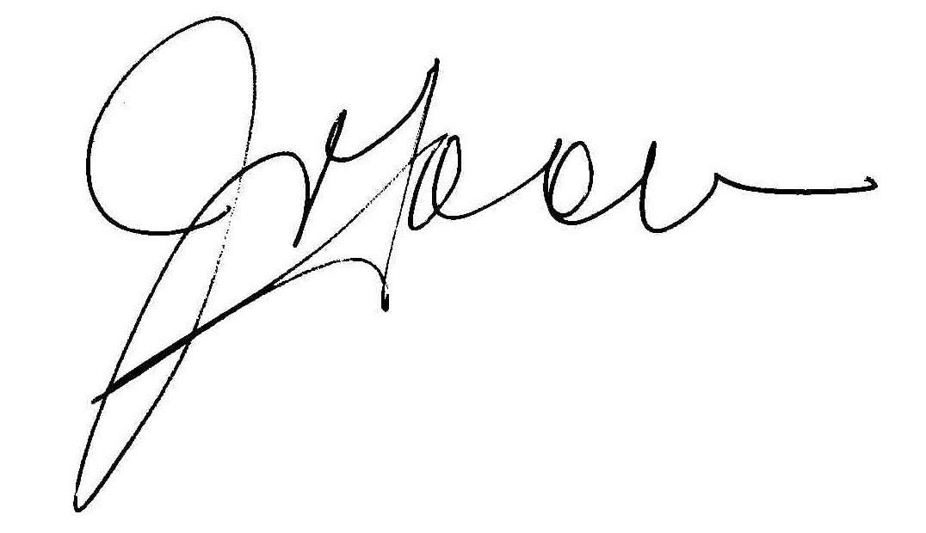

Approved by the CEO: J. Tooma Date: 30/06/2022

Approved by the Board: G. Lade Date: 30/06/2022

Date for review:30/06/2023

