POLICY TITLE | Complaints Handling Policy
POLICY DESCRIPTION | This policy documents ACCF’s the value we place on receiving concerns and complaints in all relevant communications
Date of Approval | June 2019, June 2020, June 2021, June 2022
Review Date | June 2023
Responsible Officer | Chief Executive Officer
Related Policy Framework | Child Safeguarding Policy and Code of Conduct  Memorandum of Understanding between International Partners  ACFID’s Code of Conduct  ACFID’s Code of Compliance  PSEAH Policy

- Mission, values, purpose and nature of programs

ACCF’s Mission in Australia and Overseas
ACCF’s vision and mission is to protect and enhance women’s health to help overcome disadvantage, by eliminating cervical cancer and enabling treatment and support for women with cervical cancer and related health issues in Australia and in developing countries.
The mission of ACCF is to minimise the incidence and burden of cervical cancer and related women’s health issues: to assist women, their families, and communities by developing and implementing practical and appropriate programs, and by partnering with like-minded government, organisations, and individuals to achieve health outcomes which reduce marginalisation and contribute to developing stronger communities.
ACCF’s Vision
Through its programs in support of women’s health and wellbeing, ACCF is committed to improving health and reducing poverty and disadvantage to contribute to sustainable development. ACCF and its program partners have a policy of zero tolerance to fraud and corruption and to family and sexual violence, particularly against women.
ACCF’s Purpose

The principal activities of the company are to carry out its public charitable purposes of preventing cervical cancer, by:
- Promoting and facilitating screening for cervical cancer
- Promoting awareness and prevention of cervical cancer.
- Supporting women living with cervical cancer and related women’s health issues, and their families.

- Introduction – The value of complaints and our commitment to good complaint handling.

ACCF recognises the importance and value of listening and responding to concerns and complaints. We are committed to achieving the highest standard we can in every area of our work and to continuous improvement. This applies especially to delivery of services, seeking donations and accountability to stakeholders generally. ACCF are committed to working according to or above the standard required by the Code of Conduct of the Australian Council for International Development (ACFID). Receiving concerns and complaints is one of the most important ways of learning what we need to do to improve our work.

This policy applies to all our people – board members, employees, and volunteers - and ensure they are familiarised with it. Those with relevant responsibilities are trained in its application.

ACCF makes clear the value we place on receiving concerns and complaints in all relevant communications. We advise how a copy of this policy may be obtained and we provide clear information on how complaints may be made.

- Guiding Principles

ACCF recognises the importance and value of listening and responding to concerns and complaints.
We have adopted the following principles for our complaint and procedures.

Principle 1 – Visibility
- We will clearly publicise information about how and where to complain.
Principle 2 – Accessibility
- We will ensure that our complaint handling process is as accessible as we can practically make it to all complainants.
Principle 3 – Responsiveness
- We will respond to complaints according to our predetermined timeframes.
Principle 4 – Objectivity
- We will address all complaints in an equitable, fair, and unbiased manner using evidence submitted by both the complainant and our personnel through the complaint handling process.
Principle 5 – Charges
- Access to the complaint handing process is free of charge to complainants.
Principle 6 – Confidentiality
- We will observe strict confidentially in complaint handling.
Principle 7 – Consumer/client focused approach
- The interest of our consumers/clients are foremost in our approach to complaint handling.
Principle 8 – Accountability
- We will ensure that accountability for and reporting on the actions and decisions with respect to complaint handling is clearly established.
Principle 9 – Continual Improvement
- Continual improvement of the complaint handling process and the quality of services is one of our main objectives.

- Definitions

Complaint means an expression of dissatisfaction made to an organisation, related to its products or services, or the complaint handling process itself, where a response or resolution is explicitly expected.

Complainant means a person, organisation, or its representative, making a complaint.

Inquiry means a request for information or an explanation.

Feedback means opinions, comments, suggestion, and expressions of interest in the products or the complaint handling process.

Stakeholder or interest party means a person or group having an interest in the performance or success of the organisation.

- Scope of the policy

This policy applies to any complaint, regardless of who makes it.

ACCF will accept complaints relating to our paid staff, our volunteers, our partners, our contracted service providers or anyone else acting on our behalf.

A complaint may be made by a person to whom we deliver services or goods or who is affected by our services or goods, a partner, a local organisation with which we work, our staff, volunteers, donors or a member of the public.

Anonymous complaints can be made, but obviously our ability to investigate them may be limited.

- Educating ACCF on our complaint policy and training relevant personnel

ACCF has distributed our complaints policy to all paid staff, our volunteers, our partners, our contracted service providers, and all others acting on our behalf. ACCF requires all those who may be involved in any way with a complaint to formally signify their commitment to this policy. To familiarise them with this policy ACCF will include in induction programs for our governing board members and all relevant personnel. Personnel directly involved in complaint handling are fully trained in all aspects of this policy and its implementation. ACCF takes special care to train our personnel to encourage, receive and handle complaints taking account of language issues and cultural sensitivities.

- Publicising ACCF’s policy

ACCF makes clear the value we place of receiving concerns and complaints in all relevant communications. We will use other relevant language if applicable. Our website has a prominent tab with the word complaint linking to this policy and information on how to make a complaint. Where literacy is a constraint, we will orally invite expressions of concern and complaint on a regular basis. We will take care to give this invitation in a way that is culturally appropriate recognising that in some cultures people require greater encouragement to make a complaint. We will take special care to facilitate complaints from vulnerable populations including children and marginalised groups. If required, we will make use of pictorial means of communication.

ACCF ensures that making a complaint to us is as easy as possible. We will take complaints orally in person, over the phones and by any written means. We will do our very best to assist a complainant to put their complaint in writing or to write it down ourselves as faithfully as we can.

All relevant communications explain this and explain our procedures for handling complaints including our website, partnership agreements, and our employee induction process.

- Where to whom complaints can be made
- Information to be provided by the complainant
- The process for handling complaints
- Time periods associated with various stages in the process
- The complainant can obtain feedback on the status of the complaint
In addition to the general reviews of our complaint handling specified in Section 18, ACCF will monitor how effectively we are publicising our complaints policy on a continuing basis and make necessary improvements in its communication.

- Where and how complaints are made

ACCF can receive complaints orally in person or by telephone and in writing by post, email or online via our website. Where complaints are made orally, we will ensure our write up of the complaint contains all the information the complainant wishes to provide. Complaints may be made by a friend or advocate of the complainant on their behalf. Where appropriate for some projects/programmes ACCF may establish complaint committees involving representative from partner organisation and members of the communities we are serving. Where appropriate, ACCF may utilise complaint/suggestion boxes. We recognise that in some circumstances complainants may wish to remain anonymous. Because such complaints can alert us to problems that need fixing, we will accept them, though clearly it may not be possible to provide a remedy to an individual.

- How complaints are handled

When we take an oral complaint, we will: -
- Identify ourselves, listen, record details, and determine what the client wants.
- Confirm that we have understood and received the details.
- Show empathy for the client, but not attempt to take sides, lay blame, or become defensive.
For all complaints we will: -
- Seek from the client the outcomes/s they are expecting
- Make an initial assessment of the severity of the complaint and the urgency of action
- Clearly explain to the client the course of action that will follow – if the complaint is out of our jurisdiction, if we may exercise a discretion not to investigate, if preliminary enquiries need to be made, or further consideration needs to be given OR if the complaint is to be investigated
- We will not create false expectations, but assure the client that the complaint will receive full attention
- Give an estimated timeframe or, if that is not possible, a date by which we will contact them again
- Check whether the client is satisfied with the proposed action, and if not, advise them of alternatives
- Ensure that the complaint is appropriately acknowledged
- Follow up where necessary, and monitor whether the client is satisfied
- We will register all complaints (refer to Section 16)
Where appropriate we will ensure that personnel working in communities, we serve have all necessary training to encourage and handle inquiries, expressions of concern and making of complaints to take account of cultural and general sensitivities and to ensure that cases involving children are appropriately handled.

We will ensure that a complainant is not required to express their complaint to a person implicated in their complaint. We will also ensure that a person implicated in a complaint is not involved in any way with the handling of that complaint.

Initial assessment of complaint

ACCF will first assess whether there is more than one issue raised in the complaint and whether each needs to be separately addressed. To determine how a complaint should be managed, ACCF will assess it in terms of the following criteria: -

- Severity
- Health (including mental health) and safety implications
- Financial implications for the complainant or others
- Complexity
- Impact on the individual, public and organisation
- Potential to escalate
- Systemic implications
- The need for, and possibility of immediate action
If ACCF assess the complaint as significant in terms of one or more of these criteria we will classify the complaint accordingly.

- Inquiries, minor complaints, proper complaints and jurisdiction

ACCF will endeavour to deal immediately with inquiries and minor complaints which are made orally by telephone or in person that is during the initial phone call or meeting. However, as far as possible, we will ensure that the inquirer or complainant is completely satisfied with the information and or resolution provided.

On receipt of a complaint ACCF will also attempt to determine expeditiously whether investigation is required or not depending on jurisdictional questions and whether the complaint is all conceived.

If the complainant disputes an assessment that a complaint should not be investigated, the member of staff handling the complaint will refer it to the CEO or delegate for review. If such a dispute is unresolvable, we will refer the complainant to the Code Committee of the Australian Council for International Development (ACFID).

- How complaints are investigated

ACCF will make every reasonable effort to investigate all the relevant circumstances and information surrounding a complaint. The level of investigation will be commensurate with the seriousness and frequency of the complaint.

- Timeframes

If required, ACCF will acknowledge written complaints within 5 days. ACCF will acknowledge oral complaints immediately. If a complaint is not resolved within 30 days, we will inform the complainant of progress and keep them informed of progress every two weeks.

- Responding to and closing a complaint

ACCF’s Chief Executive Officer or delegate will normally make the decision on a complaint that has required investigation (that is not a minor complaint). Decisions on serious complaints may be referred to our governing board. ACCF will communicate our decision on a complaint as soon as is practical. Our communication will be in writing in the appropriate language by email and /or post. However, where appropriate such as in the case of a complaint being made by a local community member (in the field) we will also communicate our decision orally and again in the appropriate language. ACCF will encourage the complainant to respond and advise whether they are satisfied with our decision. In our decision we will advise that if a complainant is not satisfied, we will be prepared to consider any additional information they may provide and to review our decision. In all cases ACCF will advise that the complaint may be referred to the Code Committee of ACFID. We will provide all necessary information for referral to the Code Committee and offer to assist in referral.

- Outcomes of complaints – How we learn from complaints

ACCF will ensure that all relevant personnel are informed of the outcomes of complaints and the implications for our services, goods, procedures, and processes. ACCF will take all required remedial action and we will be prepared to change the way in which we operate and improve or undertake further training of staff. Where needed ACCF will counsel or discipline staff or volunteers. Where appropriate ACCF will consult and take advice from ACFID and/or other relevant regulatory/enforcement authorities.

- Confidentiality

ACCF will not reveal a complainant’s name or personal details to anyone in or outside our organisation other than staff involved in handling the complaint without obtaining the complainant’s permission.

- Recording complaint data/record keeping

ACCF will register all inquiries and complaints and we will ensure that the following information is contained in written complaints and if not, and in the case of oral complaints, record this information ourselves:
- Date of receipt
- Description of the complaint and relevant supporting data
- The requested remedy
- The service (s) and/or good (s) and/or practice or procedure complained about
- The due date for a response
- Immediate action taken (if any) to resolve the complaint

- Reporting about complaints

ACCF will immediately escalate complex and/or major complaints (refer 6) to our Chief Executive Officer or delegate. All complaints will be reported at our regular weekly management team meetings and our governing board meetings. Minor complaints will be reported in summary form. Major complaints will be reported in detail. An analysis will be included in the complaints report provided with the complaints data.

- Continuous Improvement

On a continuing basis ACCF will monitor the effectiveness of our complaint handling and make improvements as appropriate.
We will: -
- Maintain data collection on complaints for the purpose of identifying trends for the purpose of enhancing information management and service provided
- Keep abreast of best practice (both locally and overseas) regarding complaint handling
- Foster a consumer/client focused approach
- Undertake specific training and retraining of staff to foster better complaint handling practices
- Encourage innovation in complaint handling development
- Recognise and reward exemplary complaint handling behaviour

References/Sources of Authority

Australian Council for International Development’s (ACFID) Code of Conduct effective 1 June 2017

Australian Council for International Development’s (ACFID) Code of Conduct, Quality Assurance Framework effective 1 June 2017 (7.3 ACCF is accountable to our Stakeholders)

ACFID Code of Conduct Guidelines for the Development of a Complaints Policy

APPROVAL

Contact Officer/s

Approved by the CEO: J. Tooma 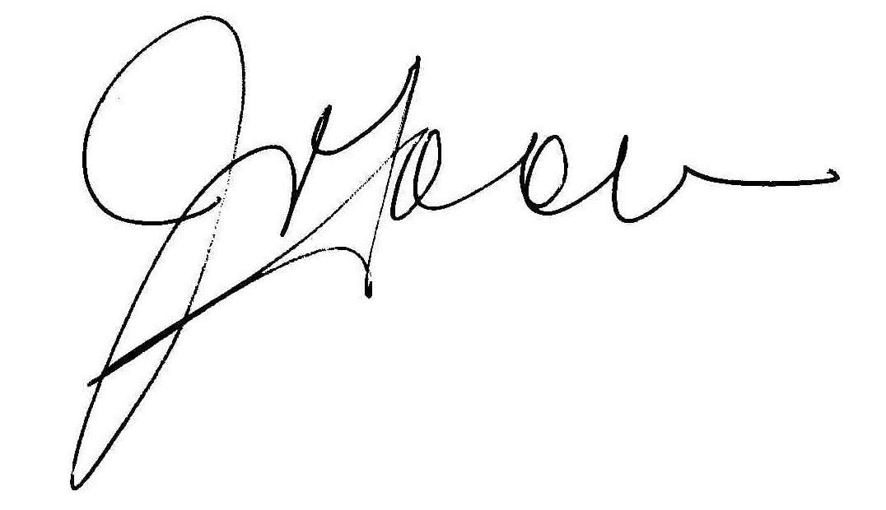 Date: 30/06/2022

Approved by the Board: G. Lade G. Lade Date: 30/06/2022

Date for review: 30/06/2023

https://accforg.sharepoint.com/sites/ACCF_Operations_and_Admin_Team/Shared%20Documents/General/ACCF%20POLICIES/1-%20Programs/Intenational/P-011%20Complaints%20Handling%20Policy.docx

