POLICY TITLE | Prevention of Sexual Exploitation Abuse and Harassment (SEAH) or (PSEAH)
POLICY DESCRIPTION | This Policy addresses the sexual exploitation, abuse and harassment of adults. It does not replace ACCF’s Child Protection Policy.
Date of Approval | December 2019, December 2021
Review Date | December 2023
Responsible Officer | Chief Executive Officer (CEO)
Related Policy Framework | ACFID Code of Conduct Policy and Code of Compliance  Child Safeguarding Policy  Complaints Policy  Whistle-blower Policy

Mission, values, purpose and nature of program

ACCF’s Mission in Australia and Overseas
ACCF’s vision and mission is to protect and enhance women’s health to help overcome disadvantage, by eliminating cervical cancer and enabling treatment and support for women with cervical cancer and related health issues in Australia and in developing countries.
The mission of ACCF is to minimise the incidence and burden of cervical cancer and related women’s health issues: to assist women, their families, and communities by developing and implementing practical and appropriate programs, and by partnering with like-minded government, organisations, and individuals to achieve health outcomes which reduce marginalisation and contribute to developing stronger communities.

ACCF’s Vision
Through its programs in support of women’s health and wellbeing, ACCF is committed to improving health and reducing poverty and disadvantage to contribute to sustainable development. ACCF and its program partners have a policy of zero tolerance to fraud and corruption and to family and sexual violence, particularly against women.

ACCF’s Purpose

The principal activities of the company are to carry out its public charitable purposes of preventing cervical cancer, by:
- Promoting and facilitating screening for cervical cancer
- Promoting awareness and prevention of cervical cancer.
- Supporting women living with cervical cancer and related women’s health issues, and their families.

Background/Purpose of this Policy

The purpose of this policy is to address the behaviour of anyone who represents ACCF, including but not limited to:-

- staff, volunteers, partners (local NGOs, affiliates and government counterparts), contractors, donors and board members.
- Board members, staff, volunteers and contractors of partner organisations implementing aid and development activities funded by or through ACCF including our international partners.
ACCF prohibits sexual exploitation abuse and harassment (SEAH). SEAH violates universally recognized
International legal norms and standards and ACCF considers such acts as serious misconduct that
may constitute grounds for disciplinary measures including dismissal and criminal prosecution.

This policy addresses the prevention of and response to, SEAH of adults. The Child Protection Policy
covers the area of safeguarding children.

This policy lays out the commitments made by ACCF and informs staff and associated personnel of
their responsibilities in relation to SEAH. ACCF commits to addressing SEAH through prevention,
reporting and response.

Key Definitions

This Policy uses the following descriptions of sexual exploitation, sexual abuse and sexual harassment, which combine international and Australian definitions:
Sexual exploitation: Any actual or attempted abuse of a position of vulnerability, differential power, or trust for sexual purposes. It includes profiting monetarily, socially, or politically from sexual exploitation of another.
Sexual abuse: The actual or threatened physical intrusion of a sexual nature, whether by force or under unequal or coercive conditions. It covers sexual offences including but not limited to: attempted rape (which includes attempts to force someone to perform oral sex); and sexual assault (which includes non-consensual kissing and touching). All sexual activity with someone under the age of consent (in the law of the host country or under Australian Capital Territory law [16 years], whichever is greater) is considered to be sexual abuse.
Sexual harassment: A person sexually harasses another person if the person makes an unwelcome sexual advance or an unwelcome request for sexual favours, or engages in other unwelcome conduct of a sexual nature, in circumstances in which a reasonable person, having regard to all the circumstances, would have anticipated the possibility that the person harassed would be offended, humiliated or intimidated.
Sexual harassment can take various forms. It can be obvious or indirect, physical or verbal, repeated or one-off and perpetrated by any person of any gender towards any person of any gender. Sexual harassment can be perpetrated against beneficiaries, community members, citizens, as well as staff and personnel.

Other Definitions
At risk adult – a person who is or may be in need of care by reason of mental or other disability, age
or illness; and who is or may be unable to take care of him or herself of unable to protect him or
herself against significant harm or exploitation. An at risk adult may also be referred to as a
vulnerable adult.
Beneficiary – a person who receives assistance as part of humanitarian relief or development
programmes.
Child – any individual under the age of 18 years, irrespective of local country definitions of when a
child reaches adulthood
Collaborators – individuals who work with ACCF as non-staff members including but not limited to
contractors and in country council members
Protection from sexual exploitation and abuse (PSEAH) – the term used by the humanitarian and
development community to refer to the prevention of sexual exploitation and abuse of affected
populations by staff or associated personnel. The term derives from the United Nations Secretary
General’s Bulletin on Special Measures for Protection from Sexual Exploitation and Abuse
PSEAH– prevention sexual exploitation abuse and harassment
Sexual exploitation and abuse focal – a person specifically designated and trained to receive SEAH
complaints and to provide support on SEAH matters

Code of Conduct within this policy

• Sexual exploitation and abuse by ACCF personnel constitute acts of gross misconduct and
are therefore grounds for termination of employment/placement;
• Sexual activity with children (persons under the age of 18) is prohibited regardless of the age
of majority or age of consent locally;
• Exchange of money, employment, goods or services for sex, including sexual favours or
other forms of humiliating, degrading or exploitative behaviour, is prohibited. This includes
exchange of assistance that is due to beneficiaries;
• Sexual relationships between ACCF personnel and beneficiaries are strongly discouraged since they are based on inherently unequal power dynamics;
• If ACCF personnel develop concerns or suspicions regarding sexual abuse or exploitation by
a fellow worker, these concerns must be reported via ACCF’s reporting mechanisms;
• ACCF personnel are obliged to create and maintain an environment that prevents sexual
exploitation and abuse and promotes any reference to ACCF’s code of conduct.

Obligations to be adhered to

Obligations of ACCF
ACCF is committed to acting to prevent SEAH by:
• Putting in place a plan regarding communication and raising awareness
• Facilitating reporting of SEAH
• Giving priority to PSEAH
• Ensuring prompt and effective response to reports of SEAH

Raising awareness and prevention of SEAH
ACCF raises awareness by:
• Instituting this policy and the associated SEAH Code of Conduct including other related ACCF policies
• Making the policy available on ACCF’s website
• Ensure the SEAH focal person is trained adequately in all aspects of SEAH
• Requires new personnel to commit to and sign the SEAH Code of Conduct
This policy to be read in conjunction with ACCF’s Human Resource obligations including conducting background reference and police checks of personnel working with vulnerable people
• Communicate SEAH Policy via:
- MOU/Partnership agreement from CEO to inform our overseas partners of this policy with further reference to ACCF’s other related policies;

Reporting
• ACCF personnel who witness or become aware of acts of PSEAH by fellow personnel or
collaborators have a duty to report immediately;
• Reports are to be made to the SEAH focal person;
• Reporting is to be conducted on the attached SEAH form;
• The Chief Executive Officer (or delegate) will be the focal person as the first point of contact. The Chair of the Board will be notified as soon as possible to ensure the report has been given priority; reports will be managed in confidence;
Response

ACCF will initiate its own fact-finding investigation into reports of SEAH as a priority using the
attached Report Form. Based on the gravity of the situation and the evidence available, ACCF will
refer the matter to national authorities for criminal proceedings as appropriate and will collaborate
with national authorities.
Upon conclusion of the investigation, the ACCF Board will make a decision on the appropriate
course of action in ACCF. This will be without prejudice to criminal proceedings at the national
level.

Disciplinary Action

ACCF will apply disciplinary measures that may include dismissal.
Disciplinary sanctions will apply to personnel who are proven to have failed to report PSEAH or to have
encouraged or condoned SEAH to happen.
Malicious reporting of SEAH without evidence or reasonable suspicions with the intention of harming
another person’s integrity or reputation amounts to misconduct and is subject also to disciplinary action.
This is distinct from reports of suspected wrongdoing made in good faith based on the judgment and
information available at the time of the report that may not be confirmed by an investigation.

Reference to DFAT policy (Extract)

Gender inequality and other power imbalances:
Available data indicates that the majority of SEAH victims/survivors are female and the majority of perpetrators are male. However, there are also other power imbalances at play. Inequalities based on the distinctions of worker/beneficiary; ability/disability; ethnic and Indigenous status; religion; gender identity and sexual orientation; age; health and poverty, can also result in SEAH. The intersection of gender with other forms of inequality can further increase the likelihood of SEAH occurring. Engagement with intended beneficiaries should be based on respect for diversity, promotion of gender equality and social inclusion, accountability, and a strong “do no harm” focus.
DFAT also makes reference to children who are at high risk of SEAH — particularly children with disability, children living in residential or institutional care, children who have experienced previous trauma or abuse, trafficked children, and gender diverse children and young people. DFAT’s Child Protection Policy can be found at www.dfat.gov.au/childprotection.

Investigation Responsibilities/Focal person

Acting CEO Contact details: E Mail barb.tasker@accf.org.au
Phone: 07 31771099

Chair of ACCF contact details: graemelade@yahoo.com.au
Phone: 07 31771099

Confidentiality

The CEO (or delegate) will treat all information received confidentially. Any employee who suspects SEAH will notify the CEO (or delegate) immediately, and should not attempt to personally conduct investigations or interviews/interrogations related to any suspected act.

Refer to reporting procedure section below. Investigation results will not be disclosed or discussed with anyone other than those who have a legitimate need to know. This is important in order to avoid damaging the reputations of persons suspected for subsequently found innocent of wrongful conduct and to protect ACCF from potential civil liability.

References

ACFID Code of Conduct Commitment 1.5 – Compliance Indicator 1.5.1
Members demonstrate their organisational commitment to the prevention of sexual exploitation and abuse, through a survivor-centred approach

ACCF Code of Conduct Policy
ACCF Whistle-blower Policy
ACCF’s Child Protection Policy
ACCF’s Complaints Policy
ACCF’s Workplace Harassment and Bullying Policy

APPROVAL

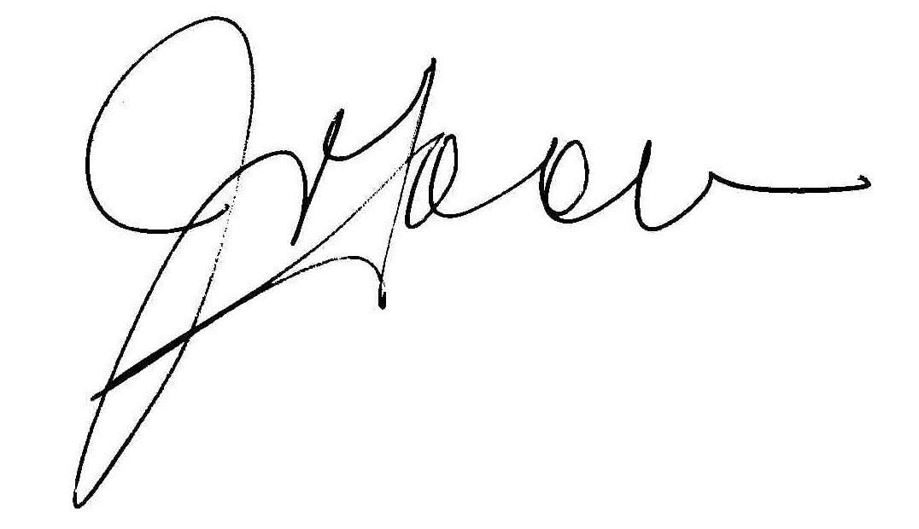
Approved by the CEO: J. Tooma Date: 30/06/2022

Approved by the Board: G. Lade Date: 30/06/2022
Date for review: 30/06/2023

https://accforg.sharepoint.com/sites/ACCF_Operations_and_Admin_Team/Shared%20Documents/General/ACCF%20POLICIES/1-%20Programs/Intenational/P-014%20PSEA%20Policy.docx

SEXUAL EXPLOITATION AND ABUSE REPORT FORM

Name of Complainant
Ethnic Origin/Nationality
Address:
Age:
Sex:
Name of Victim (if different from Complainant)
Ethnic Origin/Nationality
Address:
Age:
Sex:
Name and
Address of parents if under 18
Has the victim given consent to the completion of this form? | Y / N
Date and location of incident
Physical and emotional state of victim. Describe any cuts, bruises, behaviour
Witnesses’ names and contact information

Brief description of incident

Name of accused person Job title of accused person

Organisation accused person works for

Address of accused person

Age Sex

Physical description of accused person

Have the police been contacted by the victim? | Y/ N
If Yes, what happened?
If No, does the victim want police assistance, If not, why not?
Has the victim been informed about available medical treatment?
If yes, has the victim sought medical treatment
for the incident?

What immediate security measures have been undertaken for the victim?

Any other pertinent information provided in interview (include contact made with other
organisations if relevant)

Report completed by:
Name
Title
Organisation
Date:
Time:
Location
Signature/Thumb print of complainant signing consent form to be shared with ACCF’s focal person/delegate
Complainant’s consent for date to be shared with other entities eg. Police, Health Centre, Other (please specify)

ACCF CEO/FOCAL PERSON
Signature:
Date:

ACCF CHAIR BOARD
Signature:
Date:

